Vizard practicum week 5 A
Course: VR3d
Version: 1.3
Author: Michael Schifferling
Patrick de Beer (Unity add-on)

Assignment: Shaders
Under the hood, Vizard uses OpenGL for rendering. A powerful part of the OpenGL rendering pipeline are the programmable shaders.
For more information about shaders, you can take a look at:
- http://docs.worldviz.com/vizard/Shaders_basics.htm (do this one)
- http://www.lighthouse3d.com/tutorials/glsl-tutorial/ (this is background info; yu don’thave to do it)
On sharepoint you can find a Vizard Project with some shader setup done: “Project practicum week 5 A.zip”. In the zip file there is a vizard project and two shader files. The fragment (or pixel) shader with the .frag will be left as is. The vertex shader (.vert) will be the one you have to change.
When you start the example project you’ll see the following:
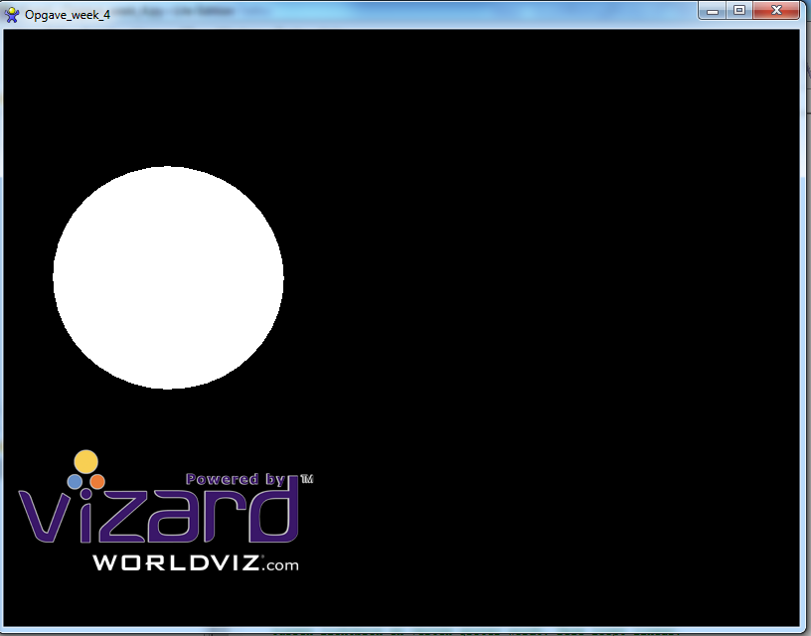
Figuur 1 Shader starting point
Lighting hasn’t been implemented yet and the sphere is plain white. We are going to fix this
by writing our own light source in shader code.

Step 1: Passing the light color to the shader.
We will start with passing the light color from Vizard to the shader.
To do this add we have to pass data to the vertex shader uniform in lightShader.vert

This can be done by using the vizard viz.addUniformFloat method.
This uniform then has to be passed to the sphere object with the sphere.apply method.

Step 2: Passing the light position to the shader.
Use the same technique as with the lightcolor. Pass a position to the vertex shader uniform:

Special gl_ functions:
If you look at the main() function in the vertex shader, you can see several functions being used that look like gl_xxx.
Which functions are these, and what do they do?

Name function | Purpose
gl_NormalMatrix | Get the normal view matrix
gl_Normal | Get the normal of the vertex
gl_ModelViewMatrix | Get the matrix of the model compared to the view
gl_Vertex | Get the position of the vertex
gl_FrontMaterial | Get the information of the material that has to be used on the front side of the vertex

Step 3: Implement the shader function CalculateAmbientColor
In this function you have to calculate the ambient color of the object.
The final ambient color should be 20% of the objectColor * lightColor.

Step 4: Implement the shader function CalculateDiffuseColor
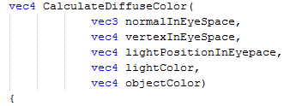

Take the following into account:
- An important factor for determining the diffuse light intensity is the angle between the lightsource and the vertex normal (see the slides at the end of week 2a).
The vector from the vertex to the lightsource (“l” in the slides) can be determined by (lightPositioninEyeSpace – vertexInEyeSpace).
We need to give that vector length 1 with function normalize.
You then need to use the dot product with the normal. Luckily there is a glsl function you can use to do this:
dot (vec4 a, vec4 b)
Question: The dot product can return a negative value. When does this happen?
- Another factor that defines the diffuse light intensity depends on the distance between lightsource and vertex. You could use the glsl function distance(vec4 a, vec4 b) to calculate this.
Use a linear attenuation when calculating the intensity. This means that at distance 0 the intensity should be 100% and at distance 100 or more, the intensity should be 0%.

Result
When you start the Vizard scene, you should see something like this:
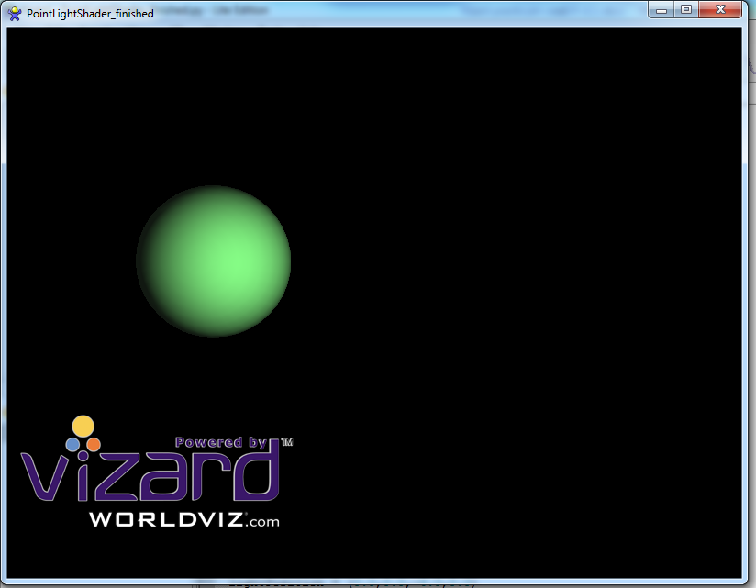
Figuur 2 Shader end result
Add the cylinder, cube or sphere you created in the previous assignment and make sure that the shader effects are also visible on that object.
Bonus assignment:
Shaders are all about giving you control over how things get rendered.
Adjust the shader to alter the light effects.
For example: switch RGB into Gray, or apply toony shading (which uses a limited number of colors instead of a continuous range:
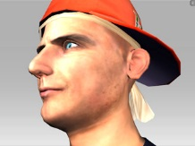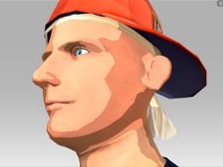
You may think of other interesting effects also.

Unity exercises week 5a

Introduction
In these exercises you will learn how to define normal of your own created primitives.
Next to that you get a first introduction how to create your own shaders within the Unity environment. In this specific case you will have a look how to implement your own lighting model in a shader language.

Assignment: Create your own shader
To get a basic understanding on how the shader languages are integrated in Unity, first have a look at the instructional video in the links. You can start from 09:00m or if you want to recap on shaders start from 06:00m.
We will be using the same example scripts used for the Vizard exercises as a starting point. They will serve as an example for our Unity scripts.
First create a similar scene as shown above and defined in Assignment_Week5_a_py. So the end result will be a white sphere as in figure 1, but now displayed in the unity environment.
The next step is to translate the fragment and vertex shader scripts from the Vizard project which are written in GLSL to the preferred CG/HLSL language for Unity.
In fact, it would be possible to re-use the GLSL scripts in Unity, however these scripts are treated as platform specific in Unity. By writing your shaders in the Shaderlab & GC languages of unity, you have the advantage that Unity will take care of translating the shaders when building for specific hardware platforms.
What specific syntax to use in Shaderlab & GC and how to attach it to your object can be seen in the video in the instructional links.
From this point on you can follow the specific step 1..4 written down in the Vizard exercise instruction. Be aware that in these steps are some GLSL specific parts of code that you have to translate to GC.

Instructional links
Examples on how to create your own Meshes:
http://docs.unity3d.com/ScriptReference/Mesh.html
Example on how to add normal to Meshes:
http://docs.unity3d.com/ScriptReference/Mesh-normals.html

Introduction to shaders in Unity:
https://unity3d.com/learn/tutorials/topics/graphics/gentle-introduction-shaders
Introduction video on how shaders are integrated in Unity:
https://www.youtube.com/watch?v=-q2GxmLOIcw
Online wiki on Nvidia’s CG language (vertex & fragment shaders for Unity are preferred in this language) and how it is used in Unity shaders.
http://en.wikibooks.org/wiki/Cg_Programming/Unity

Useful Unity concepts in this practicum
Objects: Mesh,
Types: Normal[],

